A dissertation submitted to

TongjiUniversity in conformity with the requirements for

the degree of Masterof Engineering

**Research and Implementation of Path Planning and Trajectory Tracking Algorithm for Monocular Vision Wheeled Robot**

Candidate: Wang Ziqiang

Student Number: 1531651

School/Department: School of Electronics and

InformationEngineering

Discipline: Engineering

Major: Control Engineering

Supervisor: AssociateProf. Xu Hegen

March, 2018

**ABSTRACT**

Warehouse logistics robots will work in different warehouse environments. In order to enable robots to perceive environment and plan path faster without modifying existing warehouses, we uses monocular camera to achieve an efficient robot system integration. Mapping and path planning the two main tasks presented in this paper. The direct method visual odometry is applied to localize, and the 3D position of major obstacles in the environment is calculated. We describe the terrain with occupied grid map , the 3D points are projected onto the robot motion plane, thus accessibility of each grid is determined. Based on the terrain information, the optimized A* algorithm is used for path planning. Finally, according to localization and planning, we control the robot track path. We also develop a path-tracking robot prototype. Simulation and experimental results verify the effectiveness and reliability of the proposed method.

**Key Words:** VSLAM, OGM, A*, Monocular vision, Mobile robot

Content

Chapter 1 Frame ERROR 2

1.1 INTRODUCTION 2

1.1.1 NOTATION 2

1.1.2 QUESTION IMPORT 2

1.2 SOLUTION 3

1.2.1 CONSTRUCT RESIDUAL 3

1.2.2 JACOBIAN CITATION 5

1.2.3 JACOBIAN DERIVATION 5

# Chapter1 PHOTO RESIDUALS

## 1.1 INTRODUCTION

Windowed Optimization is a classic method in non-linear optimization.

### 1.1.1 NOTATION

Throughout the paper, we will write matrices as bold capital letters () and vectors as bold lower case letters (), light lower-case letters to denote scalars (). Light upper-case letters are used to represent functions ().

Homogeneous camera calibration matrices are denoted by  as (2.1). Camera poses are represented by matrices of the special Euclidean group , which transform a 3D coordinate from the camera coordinate system to the world coordinate system. In this paper, a homogeneous 2D image coordinate point  is represented by its image coordinate and inverse depth as (2.1) relative to its host keyframe . The host keyframe is the frame the point got selected from. Corresponding homogeneous 3D world coordinate point  is denoted as (2.1).  are used to denote camera projection functions. The jacobian of ,  is denoted as (2.1)

### 1.1.2 QUESTION IMPORT

Assume we observe 5 points  in 4 keyframes , every keyframe has stereo vision  abbreviated as . A point can also be observed by other frame as shown in Table(2.1). Question is how to use Windowed Optimization method to make our observation more accurate ?

Table (2.1)

|  |  |  |
| --- | --- | --- |
| Image point | Host keyframe | Observe by |
|  |  |  |
|  |  |  |
|  |  |  |
|  |  |  |
|  |  |  |

## 1.2 SOLUTION

We use direct method to construct residual, Windowed Gauss-Newton method to optimization residual。

### 1.2.1 CONSTRUCT RESIDUAL

Dynamic multi-view stereo residuals  are defined as

 is Huber norm.  is affine brightness parameters to frame  .  is a gradient-dependent weighting parameters,  in frame  projected to  is  as:

Static one-view stereo residuals  are modified to

Hostframe of  is .  is affine brightness parameters to frame .  in frame  projected to  is  as :

Total residuals

To balance the relative weights of temporal multi-view and static stereo, we introduce a coupling factor  to weight the constraints from static stereo differently.  is a set of all image point host by frame .  are the observations of  from temporal multi-view stereo. If there are  image point and  keyframes in , optimization variable  is

In this example, there are 7 dynamic residuals and 3 static residuals, Factor graph of the residuals function is

Total residuals is

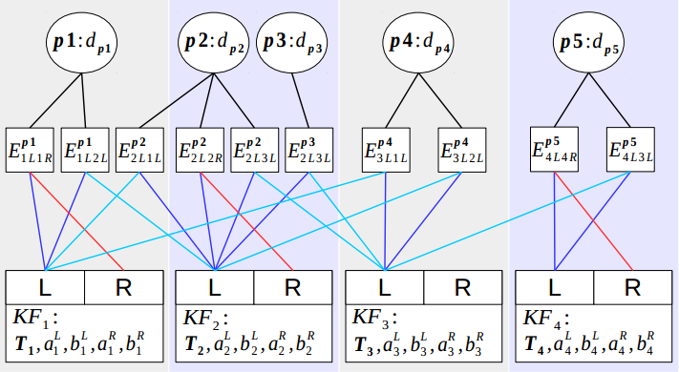

Iteration  can be calculated by

We construct residuals and its formulation.

### 1.2.2 JACOBIAN CITATION

 We know for a Lie algebra  and :

### 1.2.3 JACOBIAN DERIVATION

#### 1.2.3.1 Dynamic Parameter

Firstly, if  is neither observed by frame ,  nor hosted by , :

otherwise, we follow

For one frame , we have  and , then we can get

add detail scalar derivation…….

Secondly, according to

We have:

add detail Calibration derivation……



#### 1.2.3.2 Static Parameter

Firstly, For a stereo frame : inverse depth , a left frame  pixel  is projected to right frame  with :



Secondly, according to:

We have:

add detail Calibration derivation……

# Chapter2 INERTIAL RESIDUALS

## 2.1 INTRODUCTION

Windowed Optimization is a classic method in non-linear optimization.

### 2.1.1 NOTATION

Throughout the paper, we will write matrices as bold capital letters () and vectors as bold lower case letters (), light lower-case letters to denote scalars (). Light upper-case letters are used to represent functions ().

Homogeneous camera calibration matrices are denoted by  as (2.1). Camera poses are represented by matrices of the special Euclidean group , which transform a 3D coordinate from the camera coordinate system to the world coordinate system. In this paper, a homogeneous 2D image coordinate point  is represented by its image coordinate and inverse depth as (2.1) relative to its host keyframe . The host keyframe is the frame the point got selected from. Corresponding homogeneous 3D world coordinate point  is denoted as (2.1).  are used to denote camera projection functions. The jacobian of ,  is denoted as (2.1)

### 1.1.2 QUESTION IMPORT

Assume we observe 5 points  in 4 keyframes , every keyframe has stereo vision  abbreviated as . A point can also be observed by other frame as shown in Table(2.1). Question is how to use Windowed Optimization method to make our observation more accurate ?

Table (2.1)

|  |  |  |
| --- | --- | --- |
| Image point | Host keyframe | Observe by |
|  |  |  |
|  |  |  |
|  |  |  |
|  |  |  |
|  |  |  |

## 2.2 SOLUTION

We use direct method to construct residual, Windowed Gauss-Newton method to optimization residual。

### 1.2.1 CONSTRUCT RESIDUAL

Dynamic multi-view stereo residuals  are defined as

 is Huber norm.  is affine brightness parameters to frame  .  is a gradient-dependent weighting parameters,  in frame  projected to  is  as:

Static one-view stereo residuals  are modified to

Hostframe of  is .  is affine brightness parameters to frame .  in frame  projected to  is  as :

Total residuals

To balance the relative weights of temporal multi-view and static stereo, we introduce a coupling factor  to weight the constraints from static stereo differently.  is a set of all image point host by frame .  are the observations of  from temporal multi-view stereo. If there are  image point and  keyframes in , optimization variable  is

In this example, there are 7 dynamic residuals and 3 static residuals, Factor graph of the residuals function is

Total residuals is



Iteration  can be calculated by

We construct residuals and its formulation.

### 1.2.2 JACOBIAN CITATION

 We know for a Lie algebra  and :

### 1.2.3 JACOBIAN DERIVATION

#### 1.2.3.1 Dynamic Parameter

Firstly, if  is neither observed by frame ,  nor hosted by , :

otherwise, we follow

For one frame , we have  and , then we can get

add detail scalar derivation…….

Secondly, according to

We have:

add detail Calibration derivation……



#### 1.2.3.2 Static Parameter

Firstly, For a stereo frame : inverse depth , a left frame  pixel  is projected to right frame  with :



Secondly, according to:

We have:

